Circuit Analysis (Lab3)
Experiment 3: Introduction to Multimeter and Basic Series Circuit Implementation

Name: Waqas Ali Registration No: 2025-CE-99

Date: 30/March/2026 Grade and Signature: ………………………..

CLO2  CLO3 | Use with identification the circuit components, breadboards, multimeters, power supplies, signal generators, and oscilloscopes.  Make measurements in their own constructed electric circuits.
Psychomotor/Affective | Level1  (1) | Level2 (2-3) | Level3 (4-5) | Level4 (6-7)
Report Marks (3) |  |  | Total marks  (10)
________________________________________________________________________________ Objectives: To get understanding of how to use a multimeter and make measurements in your own constructed series circuits.
Equipment required:
Power Supply, Breadboard, Connecting wires, Resistances, Multimeter.
What is a multimeter?
A multimeter is a measurement tool necessary in electronics. It combines three essential features: a voltmeter, ohmmeter, and ammeter, and in some cases continuity. A multimeter allows you to understand what is going on in your circuits. Whenever something in your circuit isn’t working, the multimeter will help you troubleshooting.

Parts of Multimeter:

Display: this is where the measurements are displayed
Selection knob: this selects what you want to measure
Ports: this is where you plug in the probes
Probes: a multimeter comes with two probes. Generally, one is red and the other is black. Note: There isn’t any difference between the red and the black probes, just the color. So, assuming the convention:
- The black probe is always connected to the COM port.
- The red probe is connected to one of the other ports depending on what you want to measure.

Ports
The “COM” or “–“ port is where the black probe should be connected. The COM probe is conventionally black.
- A is used when measuring large currents, greater than 200mA
- mA is used to measure current
- VΩ allows you to measure voltage and resistance and test continuity.
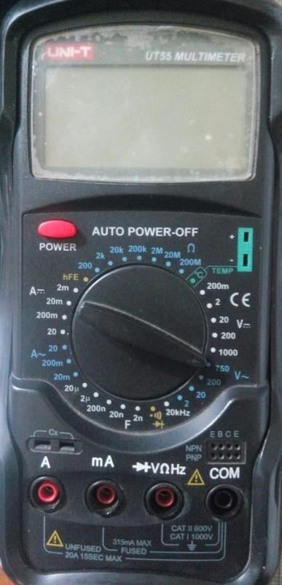
Figure 1 Digital Multimeter (DMM)

Introduction to resistance measurements
Resistance is measured with the circuit’s power turned off. The ohmmeter sends its own current through the unknown resistance and then measures that current to provide a resistance value readout.

Resistance measurement procedures
Follow the steps below to measure resistance:
- Turn off the power to the circuit. Remove or isolate the component to be tested.
- Plug the test probes into the appropriate probe jacks. Note that the jacks used may be the same ones used to measure volts.
- Select the ohms function by turning the function switch to ohms. Start with the lowest setting.
- Touch the probes together to check the leads, connections and battery life. The meter should display zero or a very small amount of resistance for the test leads. With the leads apart, the meter should display OL or I, depending on the manufacturer.
- Connect the tips of the probes across the break in the component or portion of the circuit for which you want to determine resistance. If you get an OL (over limit), move to the next level.
- View the reading on the display unit. Be sure to note the unit of measurement.
- After all the resistance readings are complete, turn the DMM off to prevent the battery from draining
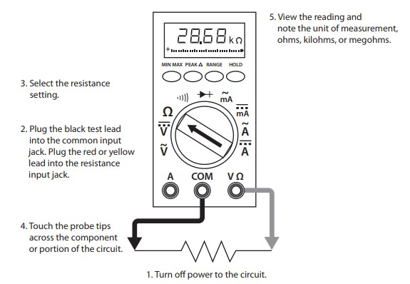
Figure 2 Using a DMM to measure resistance

Introduction to voltage measurements
Voltage measurements are very easy to make with a DMM. On meters with manual range selection, start with a value one setting higher than expected. An auto range DMM will automatically select the range based on the voltage present. Figure 4 shows the process.
Note:
1/ 1000 V=1mV
1000 V=1kV
Follow these steps to measure voltage:
- Select the DC or AC volts function by turning the function switch to DC or AC volts.
- Plug the test probes into the appropriate probe jacks.
- Connect the tips of the probes across the source or load.
- View the reading on the display unit. Be sure to note the unit of measurement. If you are testing DC voltage and a negative sign appears in the display, the polarity of your probes is incorrect and needs to be reversed.
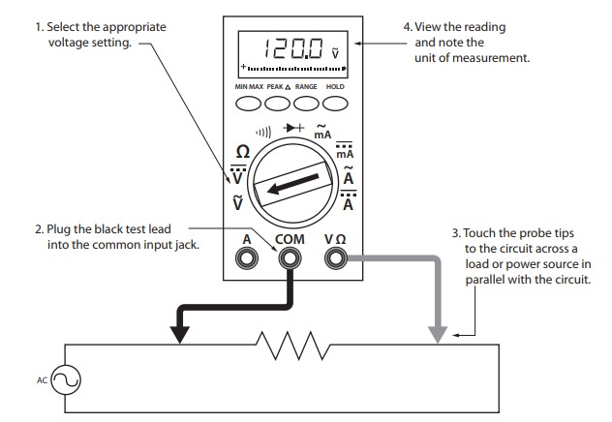
Figure 3 Using a DMM to measure voltage

Introduction to current measurements

As you have seen, the placement of meter leads for voltage measurements is straightforward. The leads are simply connected across, or in parallel with, the points of voltage to be measured. For current measurements, however, the process is slightly more complex.
First, the circuit must be opened at the test points and the meter inserted in series at that opening. The total current must flow through the meter. To allow the measurement to be made without disturbing the circuit itself, the current meter must have very little internal resistance.
If the meter is inadvertently connected across a P.D. (potential difference) or in parallel with a component instead of in series, the small internal resistance will permit a very large current to flow through the meter.
This will most certainly damage the meter severely and perhaps the circuit as well.
On meters with manual range selection, start with the highest current setting and work your way down.

Current measurement procedures
Follow the steps below to measure current:
- Turn off the power to the circuit that will be measured.
- Open the circuit by disconnecting or unsoldering a connection at a point where you wish to measure current.
- Select the DC or AC amps function by turning the function switch to DC or AC amps.
- Plug the test probes into the appropriate probe jacks. Note that the jacks used may not be the same ones used to measure volts.
- Connect the tips of the probes across the break in the circuit so that the current to be measured flows through the meter. Note that this is a series connection. Never connect the ammeter in parallel with the source or load, as this will cause a short circuit and damage the meter.
- Turn the circuit power back on.
- View the reading on the display unit. Be sure to note the unit of measurement.
- Switch power off and disconnect meter leads from the circuit.
- If testing is finished at this test point, restore the circuit by reclosing the connection. When current measurements are complete, turn the function switch to the OFF position and remove the test leads.
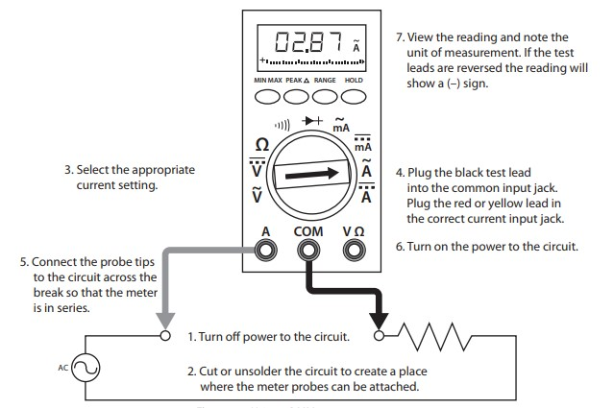

Figure 4 Using a DMM to measure current
Lab Tasks:
  - Measure Current between R1 and R2, and Voltage across R1, R2.
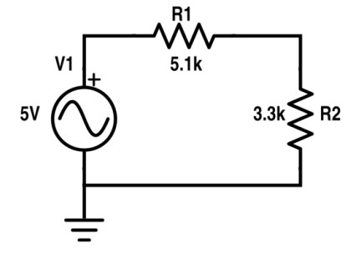
2.14V 1.39V 0.42mA
3.03V 1.96V 0.595mA
Practical Values:

R1 Voltage

R2 Voltage

Current

Theoretical Values:

R1 Voltage

R2 Voltage

Current

Procedure:

- Select Components
Click on the Pick Devices (P) option and select the following components:
    - Two resistors (R1 and R2)
    - AC Voltage Source
    - Ammeter
    - Voltmeter
    - Ground (GND)
- Place Components on Workspace
Place all components on the schematic area and arrange them properly.
- Set Component Values
  - Set R1 = 5.1 kΩ
  - Set R2 = 3.3 kΩ
  - Set AC source voltage to 5V
- Connect the Circuit
- Connect R1 and R2 in series
- Connect the AC source across the series combination
- Connect the ground terminal properly
- Connect Measuring Instruments
  - Place the ammeter between R1 and R2 (in series) to measure current
  - Connect the voltmeter across R1 to measure voltage across R1
  - Connect another voltmeter across R2 to measure voltage across R2
- Verify Connections
Ensure all wires are properly connected and there are no loose connections.
- Run Simulation
Click on the Run (Play) button to start the simulation.
- Observe Readings
  - Note the current value shown by the ammeter
  - Record the voltage across R1 and R2 from the voltmeters

  - Measure Current at node 2 and 3 and Voltage across R1, R2, R3.
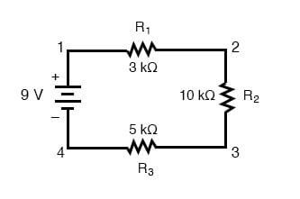
1.5V 5V 2.5V 0.5mA 0.5mA
1.5V 5V 2.5V 0.5mA 0.5mA
Practical Values:

R1 Voltage

R2 Voltage

R3 Voltage

Current at node 2

Current at node 3

Theoretical Values:

R1 Voltage

R2
Voltage

R3 Voltage

Current at node 2

Current at node 3

Procedure:
    - Click on Pick Devices (P) and select three resistors (R1, R2, R3), a DC voltage source, ammeter, voltmeter, and ground.
    - Place all components on the workspace and arrange them to form a circuit with four nodes.
    - Set the values as R1 = 3 kΩ, R2 = 10 kΩ, R3 = 5 kΩ, and DC source = 9V.
    - Connect R1, R2, and R3 in series and connect the DC source across the circuit. Also connect the ground terminal properly.
    - Label the nodes as Node 1, Node 2, Node 3, and Node 4.
    - Place the ammeter in series at Node 2 and Node 3 (one at a time if needed) to measure current.
    - Connect the voltmeter across R1, R2, and R3 to measure voltage across each resistor.
    - Check all connections to ensure there are no errors.
    - Click the Run (Play) button to start the simulation.
    - Observe and record the current at Node 2 and Node 3, and the voltage across each resistor.

Post Lab Questions - Answers
1. Define Energy:
Energy is the ability to do work. In electrical circuits, it is the capacity to supply power over time and is measured in joules (J).

2. Define Power:
Power is the rate at which energy is transferred or converted. In electrical circuits, it is given by:
P = V × I and measured in watts (W).

3. What is Charge?
Electric charge is a fundamental property of matter responsible for electrical effects. It is measured in coulombs (C). Relation: Q=I x t

4. What is a Circuit?
An electrical circuit is a closed path through which electric current flows, consisting of a source, conductors, and components.

5. What is the role of a resistor in a series circuit?
It limits current, divides voltage among components, protects elements from excessive current, and converts electrical energy into heat.

6. What is the voltage divider rule?
In a series circuit, voltage divides proportional to resistance:
Vx = (Rx / Rtotal) × Vtotal.

7. What are the features of the series circuit?
- Same current flows through all components.
- Total resistance is the sum.
- Voltage divides across the components.
- If one component fails, the circuit stops.
- It is simpler to analyze as compared to parallel circuit.

8. Differentiate between the internal circuit of voltmeter and ammeter:
Voltmeter: Very high internal resistance, connected in parallel, measures voltage.
Ammeter: Very low internal resistance, connected in series, measures current.

9. In which combination we connect DMM to measure current and voltages?
To measure current, connect the DMM in series. To measure voltage, connect it in parallel.

